LAB Logbook

Lab 1

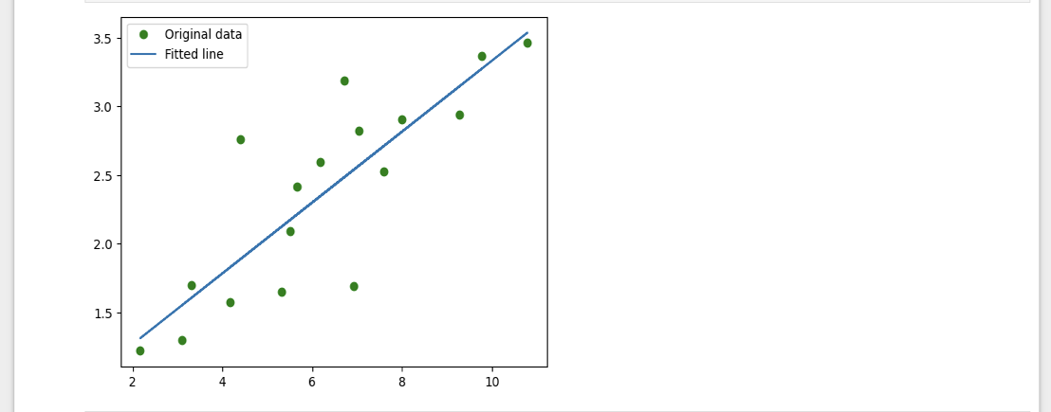

Lab 2

1. Accuracy – “0.948”
2. MLP architectures

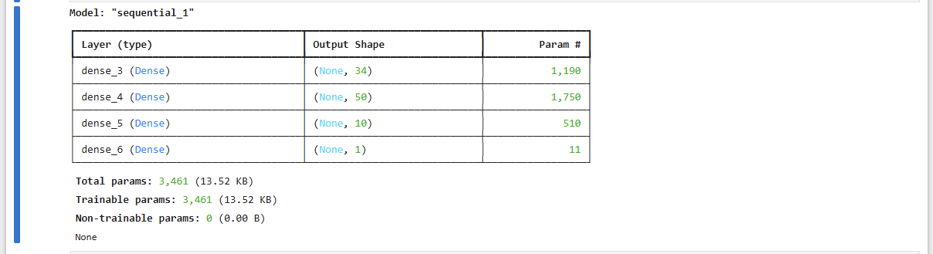

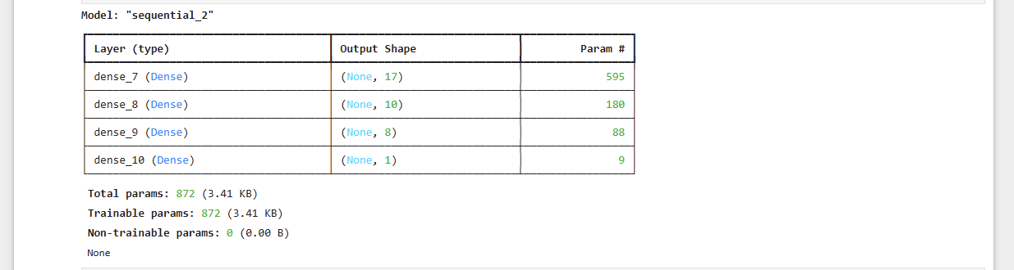3.The output of the neural network as provided in Task 2 is – “0.733”

Lab 3

Accuracy – “0.8859000205993652”

model.summary()

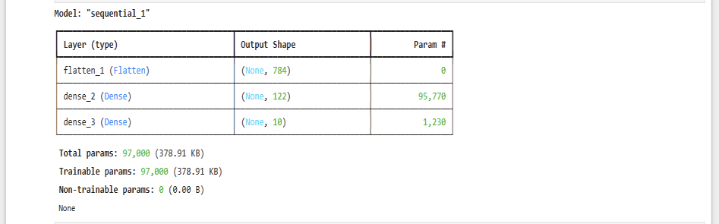

Lab 4

The model's loss after every epoch:

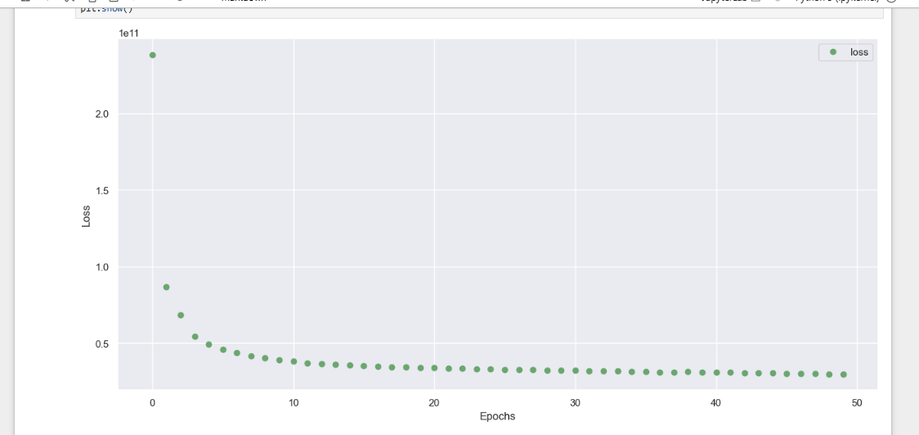

Model Summary:

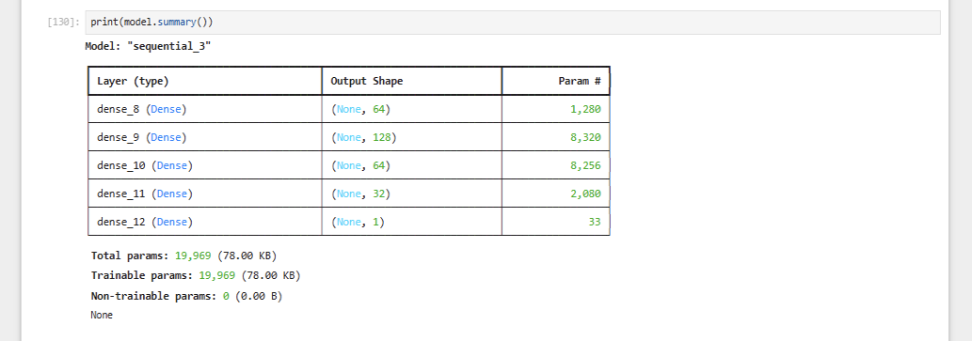

Lab 5

Model Summary:

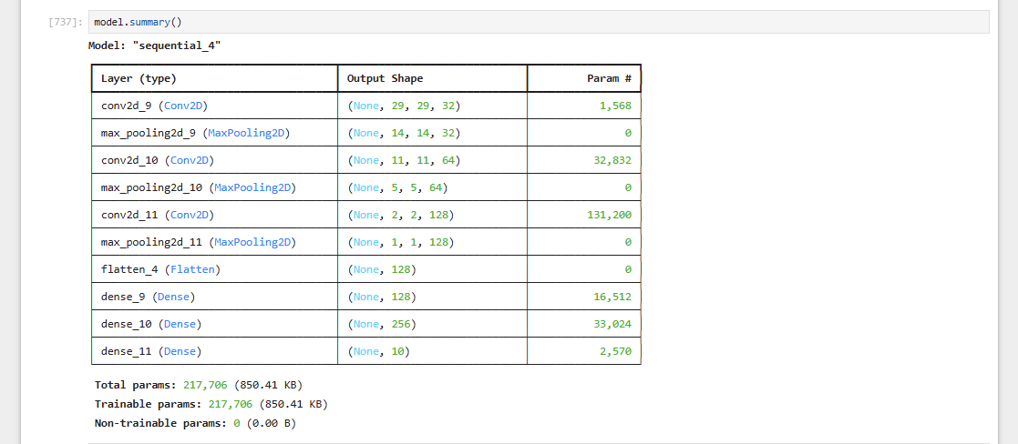

The train loss and validation loss trends

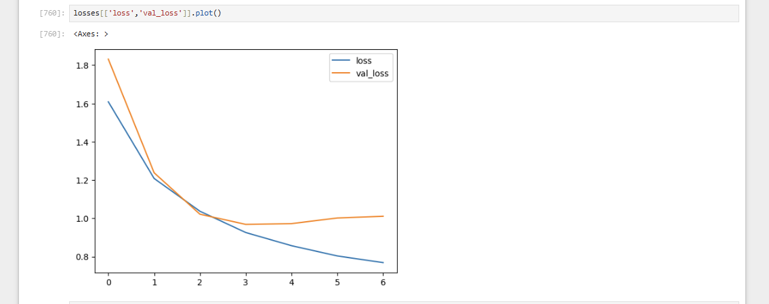The optimal number of epochs for training your model:

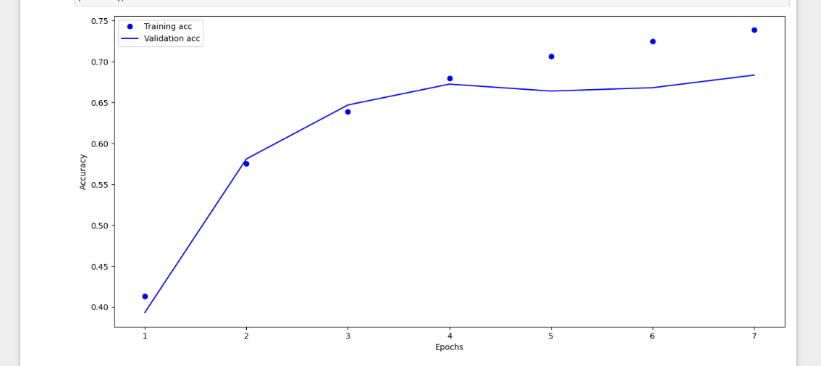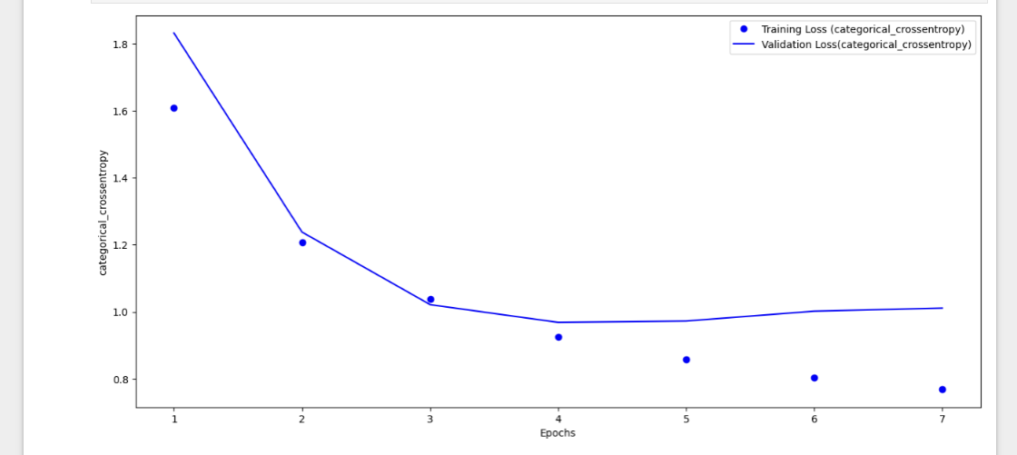

Lab 6

1.Model Summary:

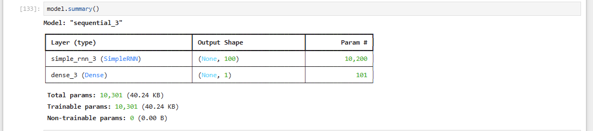

2.early-stop code and history_2 fit-training-process:

early_stop = EarlyStopping(mo nitor='val_loss',patience=2)

history_2 = model.fit(generator, epochs=30,

validation_data=validation_generator,

callbacks=[early_stop])

3.The plot of validation and test loss of history_2:

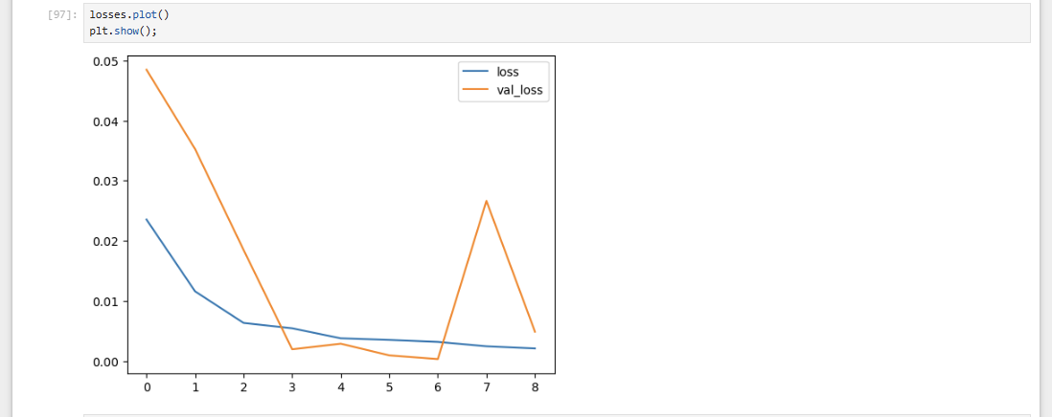4.determine the optimal number of epochs for training your model:

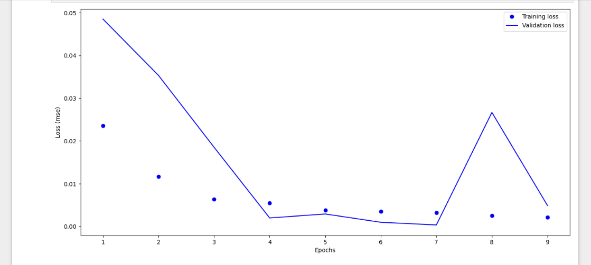

Lab 7

Lab 8

Lab 9

Lab 10

Lab 11

Lab 12